# Introduction

The purpose of this document is to establish the existence or severity of anti-competitive effects of the RRF funded investment scheme for expanding VHCN in Cyprus. The Cypriot authorities are planning on a market intervention, namely, to subsidize the expansion of high-speed internet networks to areas where such a network does not exist.

Before diving into the economic arguments that could arise in such situations, we will begin by first giving a brief description of the Cypriot markets involved and the players in them, as well as describe some economically important details of the investment scheme the Cypriot authorities have envisioned.

In the second section, we will describe the investment scheme designed by the Cypriot authorities.

The planned aid scheme will affect both the fixed market as well as the mobile market. We will explore the impact of the scheme on these markets separately, as envisaged by the draft Broadband Guidelines (BBGL). We will further explore the assumption by the Cyprus government that in the particular case of Cyprus an aid scheme can cover both markets without a distorting effect on the market.

Finally, we will dive into a few economic arguments that could be raised as objections to the scheme being implemented, and evaluate the risk that they pose towards strengthening the incumbent’s market power. Some of these will be counterbalanced by the countermeasures the Cypriot government will or has already put into place.

## Cyprus fixed broadband: the wholesale and retail markets

In Cyprus, the supply side of the telecommunication market consists of four companies: the incumbent, Cyta, which used to be a state-owned company, and three smaller companies which have gradually gained a foothold in the market, MTN, EPIC and Cablenet.

The market which is relevant for the intervention envisioned by the Cypriot authorities is the market for fixed broadband. We will distinguish between the retail market for fixed broadband, where the demand side consists of the consumers seeking to purchase internet services, and the wholesale market, where the demand side is captured by telecom companies seeking access to the network owned by other companies.

We will first give a brief summary of the distribution of market value on the retail market. To help put things into perspective, we present in the table below the distribution of market value between each of the three main segments of the telecommunication retail market: fixed broadband, but also mobile and TV services.

As can be seen from the table, the four providers have heterogeneous presence on the three segments. The incumbent, Cyta, captures roughly half of the total market value on each segment. Cablenet specializes in fixed broadband (27%) and has low presence in Mobile (1%) and TV services (13%). In comparison, Epic has a strong presence in the Mobile Market (39%) but limited presence in Fixed (9%) and TV services (0%).

|  |  |  |  |  |  |  |
| --- | --- | --- | --- | --- | --- | --- |
|  | Retail market shares[1] | | | | | |
|  | Cablenet | Cyta | Epic | Primetel/MTN | Total market value | HHI[2] |
| ***Mobile*** | 1% | 51% | 39% | 9% | 218M | |  | | --- | | 4204 | |  | |  | |
| ***Fixed*** | 27% | 48% | 9% | 16% | 124M | 3370 |
| ***TV Services*** | 13% | 69% | 0% | 18% | 30M | |  | | --- | | 5254 | |

We now turn to a quick introduction of the wholesale market. The size of mobile and fixed broadband wholesale markets are, respectively, 26M and 20M Euros.

|  |  |  |  |  |
| --- | --- | --- | --- | --- |
|  | Wholesale market share[3] | | | |
|  | Cablenet | Cyta | Epic | Primetel/MTN |
| ***Mobile*** | 0% | 68.6% | 29.6% | 1.8% |
| ***Fixed*** | 0% | 40% | 2% | 58% |

It is worthwhile noting that the supply on the wholesale market is a duopoly, on each of the two segments (mobile and fixed broadband). A constant across the two markets is the presence of Cyta. In contrast, the second duopolist is Epic for the mobile segment and MTN on the fixed broadband segment.

## The Cypriot investment scheme

The objective of the Cypriot government is to extend the access to fast internet connections (download speed > 100Mbps, upgradable to 1Gbps), and extend gigabit connectivity for SEDs (socio-economic drivers) across the island*.* Urban areas being well-connected to high-speed broadband, the objective is thus to extend VHCN to relatively more rural and peri-urban areas. The target areas (identified with a light green colour on the map below; Source: document *Investment 1)* represent a number of 93,255 buildings, 58,356 households and 80,152 population.

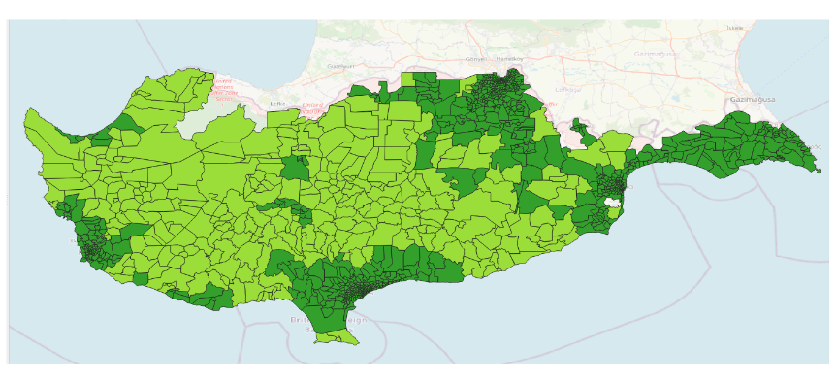

**Figure 1:** Target areas in light green.

The development cost per premise in the target regions has been estimated at EUR 1250, which is twice more expensive than for premises in urban areas. An explanation for this difference is the existence, in urban areas, of economies of scale that may exist but to a lesser extent in relatively more rural zones. As an illustration, Cyta estimates its funding gap for deploying the network to the target area at EUR 27.9 million. The incumbent’s estimates of the overall connection cost per household (i.e., network deployment and connecting the households to the network) is presented in Figure 2 below. The figure suggests the existence of economies of scale even in the target regions: e.g., if a few dozen households are connected, the cost per household is around 2000 Euros; for around 250 households connected, the cost per household drops significantly, to around 1000 Euros.

The implementation of the investments will follow a Private DBO (Design, Build and Operate) – Gap Funding model. The Contractor will undertake the design, construction, and operation of the network, as well as part of the financing, and the public sector will cover the funding gap with a grant, calculated on the basis of a percentage of eligible investment costs for the deployment of subsidized infrastructure, following an open tender procedure.

As will be explained in detail below, the geographical territory of the Republic of Cyprus will be divided into 3 lots. Each lot will include a combination of type A, B and C investments, grouped in the respective intervention area. For each lot, the maximum amount of public financial contribution will be set, and awarding criteria will include the requested public support as well as the price offered to end-users and to other retail operators.

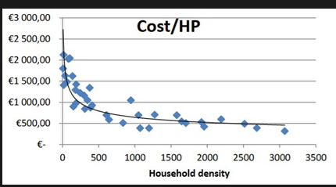

**Figure 2:** Expected overall cost of connecting a household in the target area (Source: Cyta)

The selection procedure will work by first dividing the areas that need to be serviced into 3 lots. The lots will sometimes span numerous districts. Lot A will predominantly serve Nicosia and Larnaka, will be 50% larger than the other two, and will service 35 thousand people. Lot B will predominantly service Limassol and reach 22 thousand households. Lot C will primarily service Paphos and reach approximately 21 thousand households. This is summarized in the table below:

|  |  |  |  |  |  |  |
| --- | --- | --- | --- | --- | --- | --- |
| Lot\District | Larnaka | Limassol | Nicosia | Paphos | population served | Buildings served |
| A | 43% | 2% | 55% |  | 35,648 | 37,509 |
| B | 17% | 76% |  | 7% | 22,869 | 28,694 |
| C |  |  | 6% | 94% | 21,635 | 27,052 |

The premises have been identified through a mapping process lead by the NRA in consultation with the operators. The intervention map was presented to the operators in a public consultation, with a view to exclude certain areas in case of planned private investments by the operators. No areas were named by the operators as part of their investment plans in the coming three years. This confirms the lack of economic interest of the selected target objects.

Each lot will be allocated to one of the operators via a multi-criteria auction.

## 1.3 Market participants to the subsidy scheme

The Cypriot market presents a particularity, in that the actors on both the mobile and fixed markets are the same, and the competition on the markets is intimately linked. In Cyprus there are only four established operators. This is a low number in comparison to other markets, such as France and Germany, where dozens of operators are active, or specific markets such as the Czech Republic or Bulgaria where sevral hundred operators are active. In that sense the Cypriot market is quite restricted. This is due to the small size of the market and the insular character of the market.

When the first auctions for 5G spectrum were held all four operators were awarded spectrum. Therefore, all four operators continue to compete on all segments of the market.

Based on this specificity, the Cyprus authorities have chosen to bundle the aid for the terrestrial connection and the mobile connection under a single aid scheme. The aim of the scheme is to connect underserviced base stations to a fibre backhaul, and where necessary, to finance new base stations required for the 5G network densification in underserviced areas. All operators are active in this market and would potentially benefit from the scheme.

Cablenet represents a special case, as the installation base is generally DOCSIS. However, by acquiring 5G spectrum this traditionally fixed broadband operator has made a clear move into increasing investments in the mobile area. Furthermore, Cablenet is likely to make future extensions of its network based on fibre optical solutions, rather than connecting new areas with DOCSIS solutions. As such it can be expected that Cablenet, which is currently active neither in the wholesale nor the mobile market, could particularly benefit from the aid scheme.

## Also, Cyta, Cablenet and Epic are currently investing in new infrastructure with the aim of increasing connectivity to 90% of premises by 2026. Epic has secured 19million from the European Investment Bank which will double the number of homes it can connect to the fiber network (from 25k to 50k homes).

Based on the above assessment we estimate that the scheme is *a priori* of interest to all parties. The merger of the mobile and the fixed investment will benefit all operators equally.

# The intended function of the Cypriot investment scheme

Areas of Cyprus with lower population density have been unable to access to faster internet connection speeds. As these areas do tend to connect to the internet when it is available, it seems reasonable to conclude that there is not necessarily a shortage of demand.

Instead, the reason why these areas are generally poorly connected is one of supply. Specifically, it does not appear to be profitable to develop these projects. In such a market, the main costs that usually prevent infrastructure from developing are the fixed costs. As such, the Cypriot scheme intends to use a subsidy scheme to give the providers an incentive to develop the infrastructure and serve these areas that fall outside of the economically driven investment areas.

To minimize the distortive effects of this subsidy, the government intends to use a selection procedure for the aid beneficiaries that will be open and competitive, such that the subsidy is kept to minimum and that conditions on retail pricing can be set beforehand in a clear and transparent manner.

# Market failures in presence of network externalities

Cyprus suffers from a severe inequality in fast broadband deployment between urban and rural areas. A natural explanation for under provision is *network externalities*, i.e., when a consumer’s utility depends positively on the number of other consumers using the service. In the case of broadband services, network externalities may arise as a consequence of the *subscriber effect*, i.e., when the benefit to society from adding a subscriber is larger than the benefit the subscriber derives from joining the network. E.g., suppose a network counts N users, and each individual gains a benefit of 1 from being able to communicate with any other individual. In that case, adding an N+1th individual to the network increases the total value by 2N. Of lesser importance is the *ubiquity effect*, when joining the network allows a subscriber to more efficiently engage in business or leisure activities independent of location. Typically, a subscriber living in an urban area in Cyprus, thus principally located there, may still derive value from having a fast broadband connection in a relatively more rural location (holidays, development of remote work after the pandemic, etc.)

By definition, externalities are not accounted for by market participants, leading to an inefficient provision of the good or service. Fast broadband is not deployed in any of the target areas, and households living there rely on older technologies that cannot carry speeds faster than 100 Mbps.

# Addressing potential market issues associated with the VHCN investment scheme

## Technology restrictions

Technology restrictions could decrease the number of companies willing to participate, and give an advantage to those with the highest willingness to pay for deploying the network. Market concentration would result. Restrictions should be instead on the speed the network can support, and not on the actual technology used.

The Cypriot government does not plan to create any restriction on the technology. As such, there is little reason to believe technological filtering will be an issue.

## Monopoly pricing

A potential issue may arise if the Cypriot government does not make the company which wins the selection procedure for building the network in a given area commit to either (a) allow its competitors access to the network, (b) also bid on the retail price of fixed broadband. Indeed, the failure of having none of these two conditions fulfilled will certainly lead to a situation where the owner of the newly built network has a captive demand and charges a very high price for its service.

The relationship between monopolies and monopoly prices is not as straightforward as it initially seems. Indeed, a monopolist may have less market power than firms competing.[4] This point is especially true when it comes to tendering lots. Therefore, it is crucial that the criteria for the selection procedure be carefully selected.

An important criterion to determine is the weight of the **expected price to be charged to consumers** in the future. For example, if there were to be a competitive selection procedure where a single firm receives operational rights, and if further the bidding amount is a commitment to the price that will be charged to consumers, then we will have a competitive outcome even if the selected bidder has a local monopoly. In the ideal scenario the Cypriot authorities would simply ask each of the possible operators to submit the cost they would be willing to charge consumers and take the lowest one. The reserve price literature also indicates that the authorities should try and create a maximum price that can be charged to consumers, probably based on current pricing.

The ideal scenario is somewhat thwarted because there are three additional constraints that the government of Cyprus must take into account. **The first additional criterion is the number of consumers serviced**. Introducing this as a criterion could increase the risk of having the providers compete on the number of consumers serviced and not on the price they would charge them. On the other hand, this criterion could be welfare improving if it allows for more providers to enter the process, and thus compete on the retail price. This could ultimately push the participants’ bids about their retail prices down, and ultimately benefit consumers.

**The second additional criterion is the total price of the lot**. This criterion is, in our view, slightly more problematic than the first. To illustrate, let us take an example. From both a firm and the government perspective, a bid of 10M and a subsidy of 12M is equivalent to a bid of 8M and a subsidy of 10M. Therefore, a potential risk related to the subsidy is that it inflates the companies’ bids – which comes at no cost to the company bidding, but that is however costly for the government. Later in this document (section 4.3, paragraph 5), we propose possible alternatives to this criterion.

Finally, the **third criterion the government will require is the quality of service (speed of the connection) to be provided.** This constraint however is unlikely to reduce competition as the providers who will participate can all meet the required standards.

The Cypriot authorities will also take into consideration the environmental impact which can entail some trade-offs. Specifically, Fibre has the lowest CO2 footprint per Megabit transmitted and 5G would have the highest impact. On the one hand the government wants to encourage faster internet which encourages less fibre, and on the other it encourages fibre by having an environmental standard. We do not believe that the environmental criterion would have any anti-competitive effect.

## What is the expectation from the bidding?

What we can currently say is that there exist areas that the providers do not reach. Why does this occur? The most basic reason is that it is not profitable to do so. The simplest representation of this is to say that the net present value of the project (NPV) is negative for all players.

Though to our judgment it is likely the NPV is negative, there could also be game theoretic reasons why we see no investment even though the NPV is positive. Specifically, for Cyta which is (1) required to give wholesale access to its network to other providers, (2) likely one of the most efficient operators, it is possible that the project could be profitable but lack of monopoly on the retail price causes Cyta to not invest. In summary, for Cyta, we must assume that the wholesale NPV is close to zero because of regulation and that the retail NPV is not sufficient to overcome the cost of investing. [5]

For other players who can potentially develop this infrastructure and are not obligated to give wholesale access if funded by own resources, such as Cablenet and Primetel, we can make a different inference. This is because these players would have the potential to make both wholesale profits and retail profits had they developed infrastructure in these areas. Given that they have not developed infrastructure, we can say that the **total NPV** of both Cablenet and Primetel must have been negative after taking into account the fixed costs of developing the infrastructure. If the Cypriot government were to retain this present asymmetric structure where Cyta must give wholesale access but not its competitors, it seems that Cyta would only bid based on the difference between its retail NPV and its cost of development, whilst Cablenet and Primetel would bid on the difference between the maximum of the retail price and wholesale price from the cost of development. In other words, competitors might be ready to bid on the lot even if they do not expect it to be profitable for them to operate it, because they can just rent it to Cyta so Cyta can operate it.

So why would companies invest in these lots if the NPV is negative? We now come to the reason why the subsidy is necessary. The subsidy is meant to act to overcome the fixed cost. Since the subsidy for each lot is just below Euro 12 million, this means we expect that the bid amounts will be strictly less than Euro 12 million.

If the Cypriot government requires that the winner of the selection procedures give wholesale access to its competitors, as is currently intended, the result could be lower (bids) prices on the lots for all bidders. This is equivalent to saying that the profits of all competitors must be of the same form as Cyta, which is the difference between the NPV of retail and the NPV of development. The annual retail profit of the firm is given by -- where p is the annual retail cost, c is the annual cost of having a user on the network, and Q is the number of users. Over a period of time this is, where t is the year and i the firms annualized internal rate of return. The complete profit of the firm is ; where F is the fixed cost of developing the infrastructure, and S is the subsidy. We know that this is the maximum willingness to pay each firm has. We know from the argument above that without the subsidy, the sum of the first two terms is negative.

Whether operators know or do not know the total profitability of their competitors can be both beneficial or harmful depending on the circumstances. If the operators know that their competitors have very similar cost structures then we can expect transparency to give an outcome very close to the marginal costs, which would be the best possible outcome for consumers. If, however, some of the operators have a much higher total profitability than their competitors and know that this is the case, then we can expect them to bid significantly less aggressively, in line with that they expect their competitors to bid. In other words, if we expect supplier to be symmetric with respect to their efficiencies, then transparency of the cost structures is a good thing. If instead we expect an asymmetric situation, then transparency could be detrimental consumers – however, this conclusion is mitigated by the fact that at present, they cannot access fast broadband services. In practice it is difficult to infer which case we are in. Cyta does have a lower cost to operate but it is not clear if it is because it is more efficient than its competitors or because it has more users per construct.

# Bidding behaviour

From auction theory we have a few expectations. We expect that if only a single firm can credibly develop the lot with a Euro 12million subsidy, and this firm is aware they are the only one who can do so, then we would expect this firm to bid as close to zero as possible. The provider has no incentive to bid any higher than it has to secure a lot because it does not face any competition, as such, its optimal strategy would consist in minimizing its bid. On the other hand, if there are two firms who can credibly develop this project, then we expect the bidding behaviour to be about half of what the project is worth to them, which in this case would be 12million+NPV (which we expect to be negative as it includes fixed costs). So if the NPV of the project is -2million, we would expect that two bidders will opt for 5million as their bid. If there are 3 bidders, then we expect them to bid ¾ of the value, so 7.5million, and if there are four equally credible bidders, we expect them to bid 4/5 of their value, or 8million. [6]

What will be the effect of the retail price bid? In general, it is expected that the lower the retail bid, the correspondingly lower will be the bid for the lot. The scheme could use a desired price index as a starting bid or it could just fix a low price form the beginning. Nevertheless, this should carefully be weighted against the risk that the 12million+NPV amount does not go into negative territory as this could mean the operators do not participate. In general, the government must make a decision for the length that the retail price bid will commit the firm to charging this said price. For instance, if they bid for providing internet services for 30 euros a household, are they legally mandated to keep this up for 5, 10, 15 years? This also needs to be carefully crafted such that the provider does not wish to simply rent this out to a competitor who is not bound by such an agreement. In other words, the constraint must apply to anyone using this network. A similar obligation must be imposed for the number of households that the operators have committed to serve.

Finally, the coverage of the target area is another criterion the government considers important. Specifically, the government aims to use the number of buildings connected as the measure of success. The coverage aspect should be considered complementary to the retail price. For example, suppose the bid takes the following form (retail price, lot price, coverage). If the government deems that (20 euros per person, 10million, 20k buildings) is equally as attractive as (40 euros a person, 8million bid, 20k buildings), then an increase in coverage, say from 20 to 22 in both packages, should lead the government to prefer the first package to the second. This is because those extra two thousand buildings will receive the service at a lower retail price and hence the program should be better for consumers. Note that from the point of view of the company, the monetary transfer is all that matters, that is, there is no sense in using the subsidy amount as a criterion, since the lot price already encompasses the net transfer of cash from the government to the company (if subsidy>lot price) or from the company to the government (if subsidy<lot price).

# Suggested selection criteria

Since no selection procedure has been proposed as of yet, we aim in this section to outline some selection criteria that would align with the goals of the Cypriot authorities. We propose to rank companies according to their bids, where each bid will be associated with three scores (Score1 for the retail price, Score2 for the actual bid for the lot, and Score3 is a environment-related score). The winner is the company whose weighted-average score is the highest. The weights on the three scores can be changed. Below, we propose the following weights: 0.5 on Score1, 0.45 Score2 and 0.05 on Score3.

Score1 is related to the retail market. Score1 could be a function of the following variable, S :

Where:

* C has to be determined by the government. We propose that it could either correspond to the average annual cost per customer or to some price index or minimum price,
* Q is the number of premises served (part of the company’s bid),
* P is the annual retail price (part of the company’s bid).

In a given lot, the company whose bid gives the highest value of S wins the procurement.

S is maximized when the annual retail price (P) is zero and all the buildings (Q) are connected. Since there are around 30000 buildings, then a score of 100/100 is granted when S equals its maximum of 30000*C. The minimum value S can take is when Q is at its minimum, which is 15000, and when P is at its maximum. The maximum annual price P currently on the market is 66*12, which is around 800. As such, the minimum score should be: 15000(C-800)[7].

Thus, for any given offer, S, to construct the score out of 100, we simply do the following operation:

Score2 depends only on the actual bid for the lot. The minimum lot price bid is zero or some minimum reserve price chosen by the government; let us call it K. The maximum price is the subsidy amount, 12million, which would mean that the provider is willing to not accept a subsidy at all. In this case the score is then:

Finally, a simple pollution score could also be constructed, where the very pollutant 5G can be scored at a 0 and the least polluting Fibre can be scored at 100 and other technologies placed in-between.

For convenience the Cypriot government can then weight each of these accordingly. A suggested weighting function is the following:

That is, half the weight on the number of consumers and the retail price charged in the end, another 45% on the subsidy demanded, and a final 5% on the environmental impact.

A more general function would be:

Where

. The weight is the weight the authorities put on the surplus of the consumers located in the target regions, i.e., those who will directly benefit from the internet availability. The weight measures the weight the authorities will put on public spending. . Indeed, recall that Score2 – by which is multiplied – measures the ratio of the subsidy over the actual cost of the investment borne by the operator. Last, the weight can be interpreted as the weight that the authorities put on the welfare of next generations. A deterioration of the environment would cause damages that will be more likely to affect future generations.

Our general recommendation is to set the values of the weights and close to each other. Our argument for this is that Score1 and Score 2 may be intimately correlated. Indeed, we believe a positive relation likely exists between the subsidy level and retail prices, as explained in Section 4.4. There, we argued that more competition in the procurement process might be synonymous with higher bids and lower retail prices; in turn, higher bids imply a lower subsidy; hence lower public spending. If such a relation exists, a marked discrepancy between the two weights may have the following unfortunate effect. The operators may be incentivized to base their bidding strategy on only one of the two dimensions. E.g., if is high and is low, the operators may offer low retail prices but low bids on the lots. Lower bids entail higher subsidies, hence higher levels of public spending.

# Welfare effects on the retail market

The first question (Q1) we raise is whether the creation of new market segments in Cyprus (i.e., the target areas) could lead to price changes in already existing ones. The second question (Q2) we investigate is more straightforward. We propose a discussion on the criteria the aid scheme should have to maximize the consumer surplus of the households in the target regions. These households, contrary to those located in urban areas, do not have access to fast broadband services yet.

The companies that will win the procurement will continue to compete against other companies in the markets they already serve outside the target areas. It is crucial to understand whether the aid scheme could, indirectly, decrease consumer surplus in the areas that are not targeted by the intervention. Roughly speaking, these non-targeted zones can be identified as urban areas. In our view, a key determinant of the effect of the aid scheme on consumer surplus in urban areas is whether the Cypriot government wishes to enforce uniform pricing or not.

The principle of uniform pricing is a regulatory obligation on companies to charge the same price for a good or service to all their consumers, regardless of their differences. In practice, consumers with different characteristics – such as their geographical localization – represent different markets. Besides, a company can face different competitors on the different market segments it serves. If no regulatory obligation compels companies to apply the same price in every region, then the different regional markets can be considered independent. Regions with higher average costs will be served at a higher price than urban regions where the cost of connecting a household is relatively cheaper. When segments are independent, the price can vary depending on the regional cost of connecting consumers to the network. If companies are not allowed to price discriminate consumers based on their location, the several market segments are correlated. For the sake of argument, suppose that company X has invested in deploying the BB network in rural area A. Typically, its cost for serving that particular segment is high – X has to recoup the fixed cost of building the network, and local conditions may just make it more difficult to connect households. Company X is also active in the retail market for fixed BB in region B (an urban region that is relatively cheaper to serve) and faces competition from company Y. Company Y, however, is not present in region A. Uniform pricing disadvantages X on segment B. This is because the average of X’s marginal and average costs over the two regions it serves are higher than on segment B. Because of this, X can no longer offer as cheap a price on segment B; this ultimately benefits its competitor, Y.

It seems to us that uniform pricing involves a trade-off between decreasing the incumbent’s market power and decreasing consumer surplus in urban areas. Uniform pricing prevents a firm from setting a high price and cashing in on its captive consumers. This may give small firms with weaker financials than Cyta an additional incentive not to participate in the program. A pessimistic -- though realistic -- scenario would be that Cyta takes on most of the targeted areas. Its prices may rise, and Cyta may thus lose customers in urban areas to its competitors. The inflation in Cyta’s prices would not necessarily lead to a decrease in consumer surplus if it were charging higher prices than its competitors. Indeed, this could even positively incentivize captive consumers (because of high search costs, brand loyalty, etc.) to turn to cheaper operators. However, as seen in the table below, Cyta currently offers the most affordable plans. Hence, the most modest households may be particularly affected.

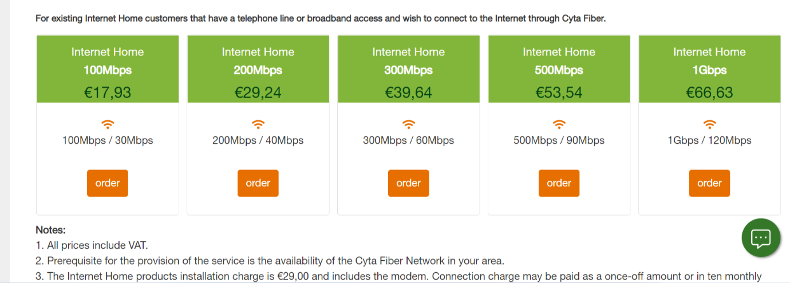

**Figure 3:** Cyta’s retail prices – fast BB services



**Figure 4:** Cablenet’s retail prices – fast BB services

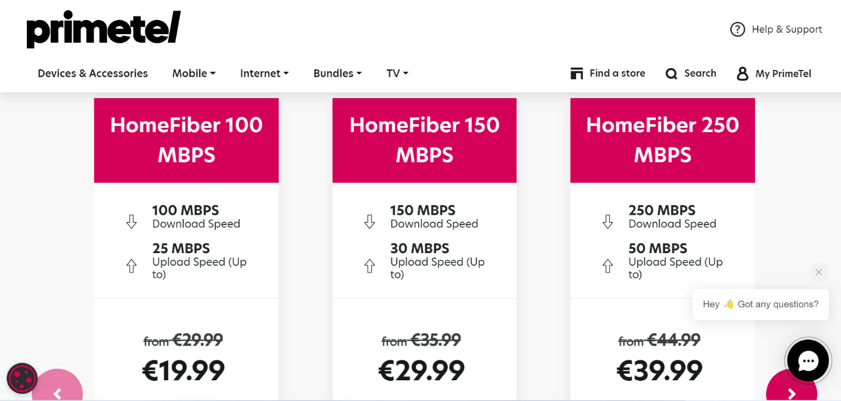

**Figure 5**: Primetel’s retail prices – fast BB services

We believe that the Cypriot aid scheme is immune to price increases in the regions outside the targeted areas. Indeed, the authorities have decided to allow differential pricing: a company that wishes to participate to the procurement bids on the retail price in the target region, and this retail price does not have to equal the price it charges other segments. This answers Q1; I.e., the possibility of differential pricing will, in our view, prevent negative repercussions of the aid scheme on the consumers outside the target areas.

The virtue of differential pricing is that it will boost participation, as companies can count on earning higher profits in the regions where they invest. The downside, however, could be high-priced services in the target regions. The Cypriot authorities' bidding system tackles this issue without depressing participation. Indeed, companies bid, among other things, on the retail price of the broadband services they will offer should they win the procurement. In other words, the aid scheme has been designed so as to incentivize participants to set competitive prices on the retail market. Second, the Cypriot aid scheme requires from the lot winners to give wholesale access to their competitors. This obligation limits the risk of very high retail prices. Third, the Cypriot scheme incentivizes participants to commit to serve many consumers, as that dimension is a determinant of their score thus of their probability to win the procurement. Going back to Q2, we believe that the three following criteria: (1) obligation to bid on the retail price, (2) commitment to a number of premises served, (3) legal obligation to provide network access to competitors, are necessary requirements for maximizing the surplus of consumers located in the target areas.

# Conclusion

In conclusion, from standard economic theory, we conclude that the subsidy is the least distortive way that the government can achieve its goals. This is because it simultaneously gives a good incentive to the providers to develop said infrastructure by using a subsidy, whilst using competition against the providers so that the subsidy is kept to a minimum. This is achieved by an auction that will function on three criteria (retail price, net monetary transfer, and coverage) and numerous conditions such that standard agreements are met.

1. This data is collected by the national regulatory authority of Cyprus (henceforth, NRA).
2. The Hershfindal Index is computed by squaring the market shares*100 and summing them
3. NRA data.
4. This point was first introduced in the economic literature by the article: Demsetz, Harold. "Why regulate utilities?." *The Journal of Law and Economics* 11.1 (1968): 55-65.
5. The winners profits are: max(retail NPV, wholesale NPV) – NPV of fixed cost
6. This assumes that firms put a uniform distribution on other firms’ willingness to bid
7. Note that this can be negative without affecting the result